Basic – URL Shortener Application

**Objectives :**

* This app will allow user to use the Short URL instead of Long URL, which can be harder to follow and interpret.
* Now a days all social media platforms are allowing users to post the various links in order to enrich the engagements.
* Thus, in-order to keep your post viewer more interested with less attention span we can simply map few character representing entire long URLs.

**Why ?**

* This can be significantly helpful if, any platform has character limit for posting link.
* Not to mention that posting long URLs might annoying to viewer and also it’s tedious task to copy and past big chunk to string.
* Hence, with this one can easily copy URL on one click.
* As, this application will be intermediatory we can easily do analytical study (like number of clicks, regions of users, peak time of clicking among various users etc.).

**Techstack :**

1. Front-end [Vanilla – HTML, CSS, JS]
2. Back-end [Flask v2]
   1. Database [SQLite3]

**Dependencies :**

1. Flask-SQLAlchemy [ORM, SQL Toolkit]
2. Flask-Migrate [To handle DB migrations]
3. Other miscellaneous

[Find full list of requirements.txt](https://github.com/sauravpanchal/irl/blob/main/Week%203/Flask/Task%20-%203%20(Basic%20-%20URL%20Shortner%20Application)/basic_url_shortner_app/requirements.txt)

**Front-end :**

* Home :
  + Here user will be prompted to enter long URL in input box.

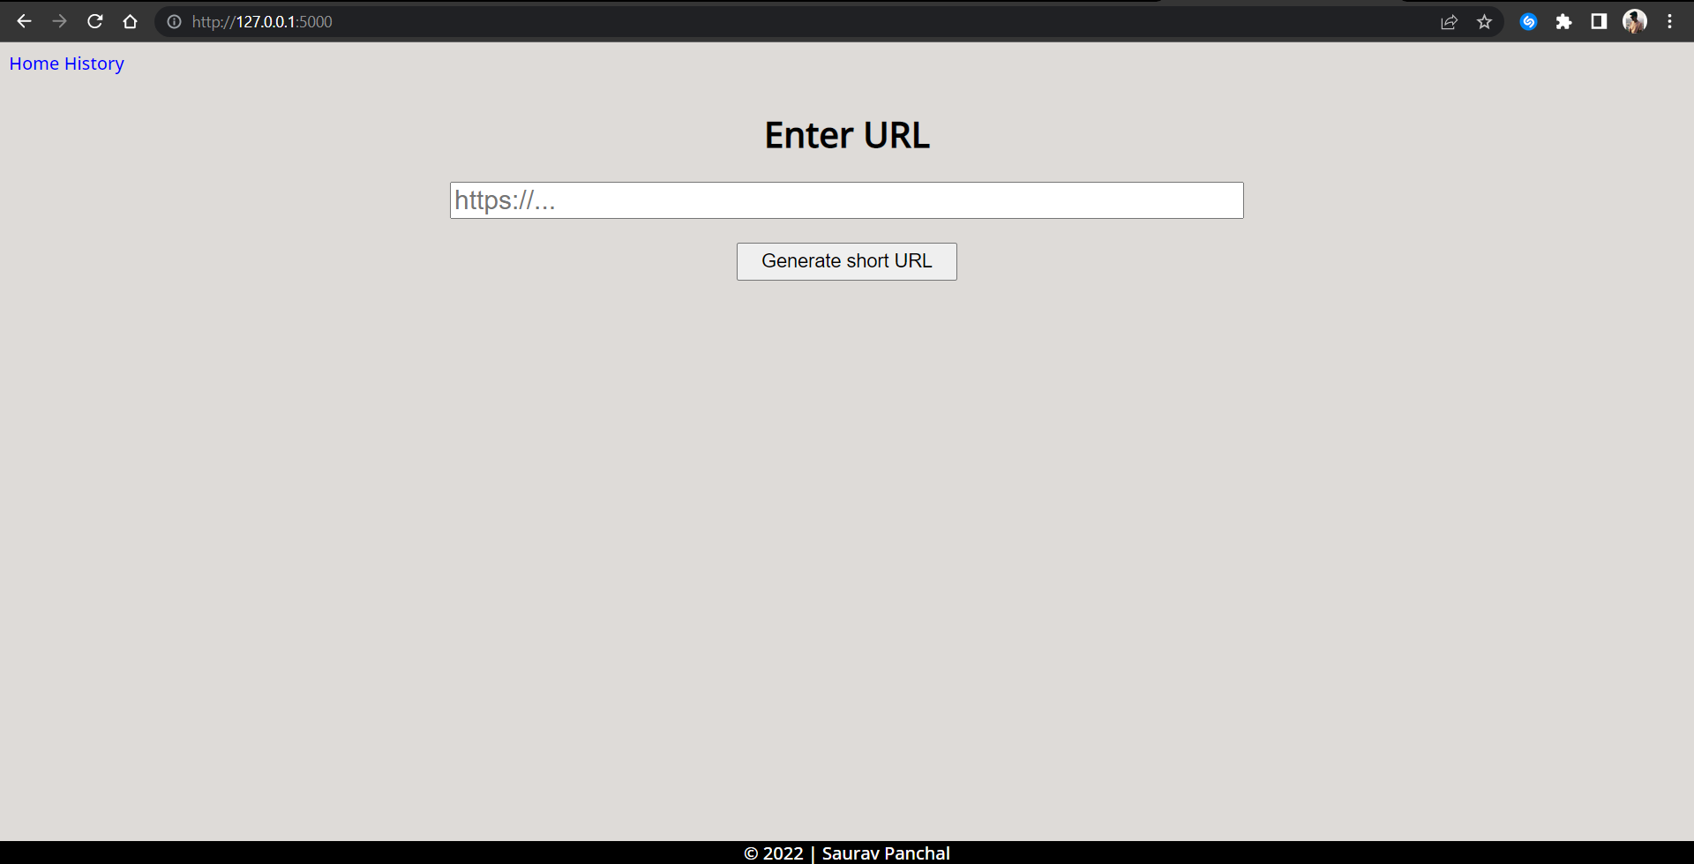

* + The input box checks user-side validation whether it’s a valid URL or not.

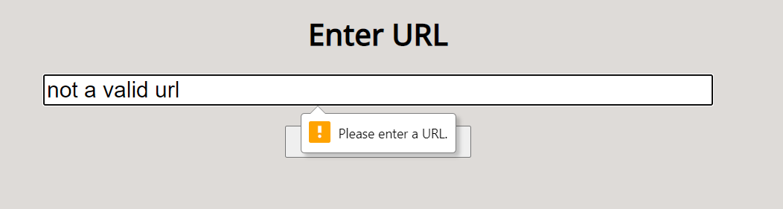

* + Then, upon entering valid URL user can generate short URL, which then be copied via, just a click.

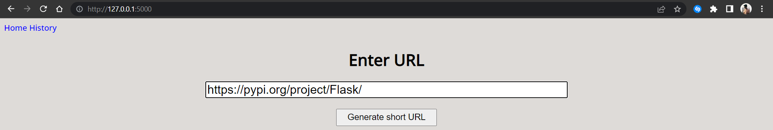

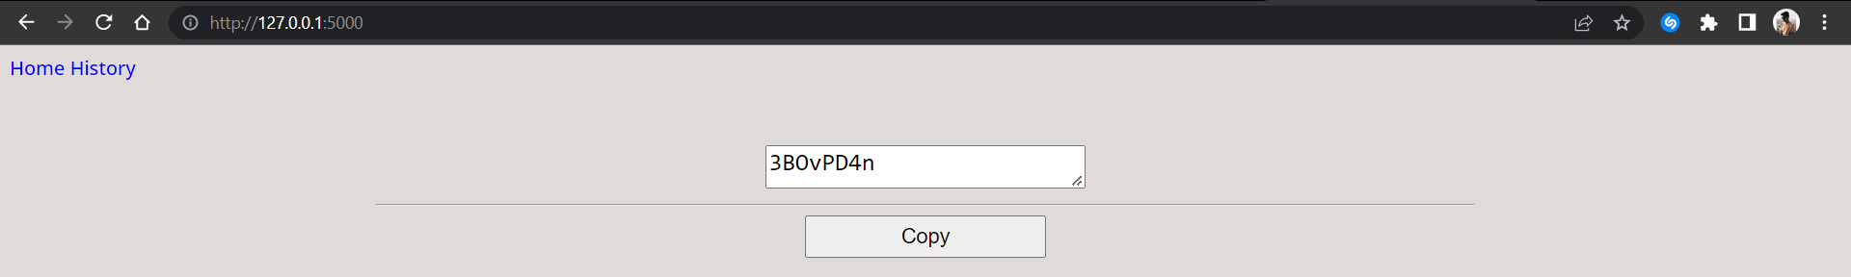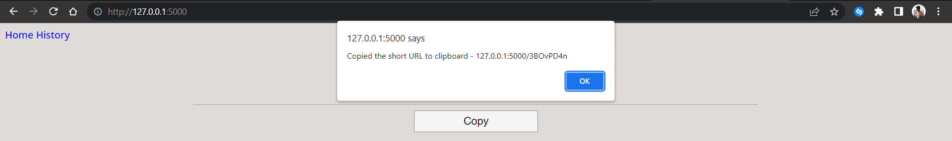

* History :
  + While user is free create as many short URL they want but, to keep track all their short URL a dedicated history page is built.
  + Here, one will be able find total number of short URLs, long URLs, short URLs and their visit count.

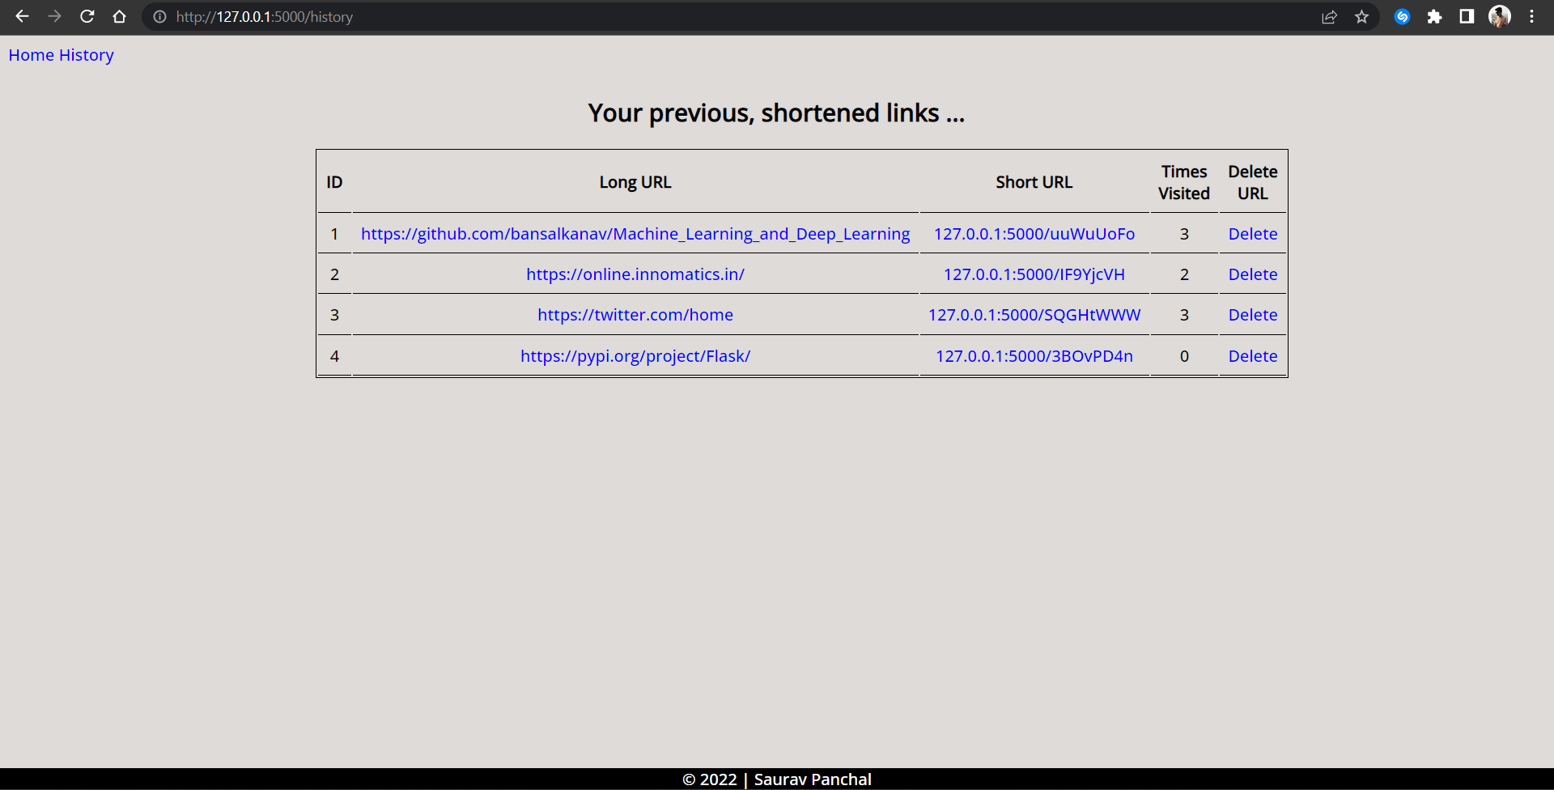

* + Visit count get incremented every time user clicks on short URL.
  + Like, on clicking <https://online.innomatics.in/> corresponding short URL having visit count 2, it will be incremented by 1, and same will be reflected in database.

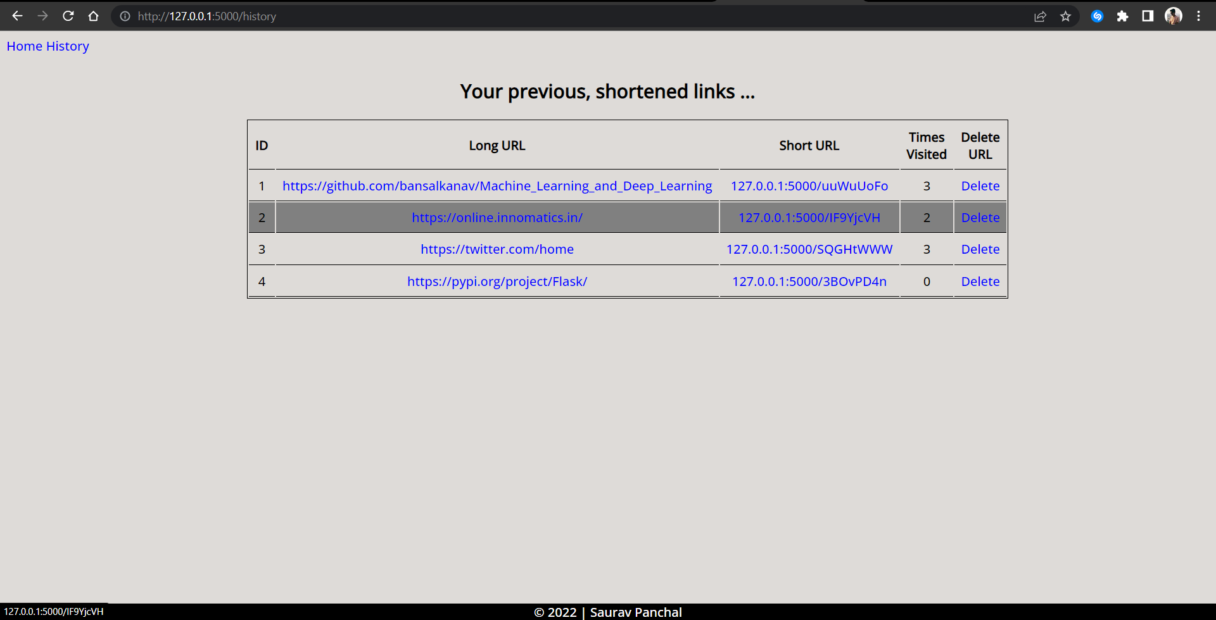

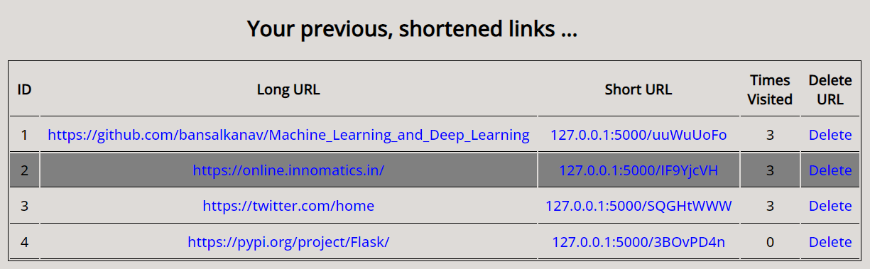 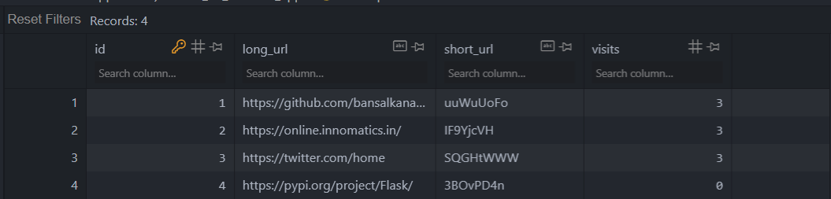

* + Also, user can delete the short URLs to keep everything clutter-free and organized
  + Like, deleting this hovered row.

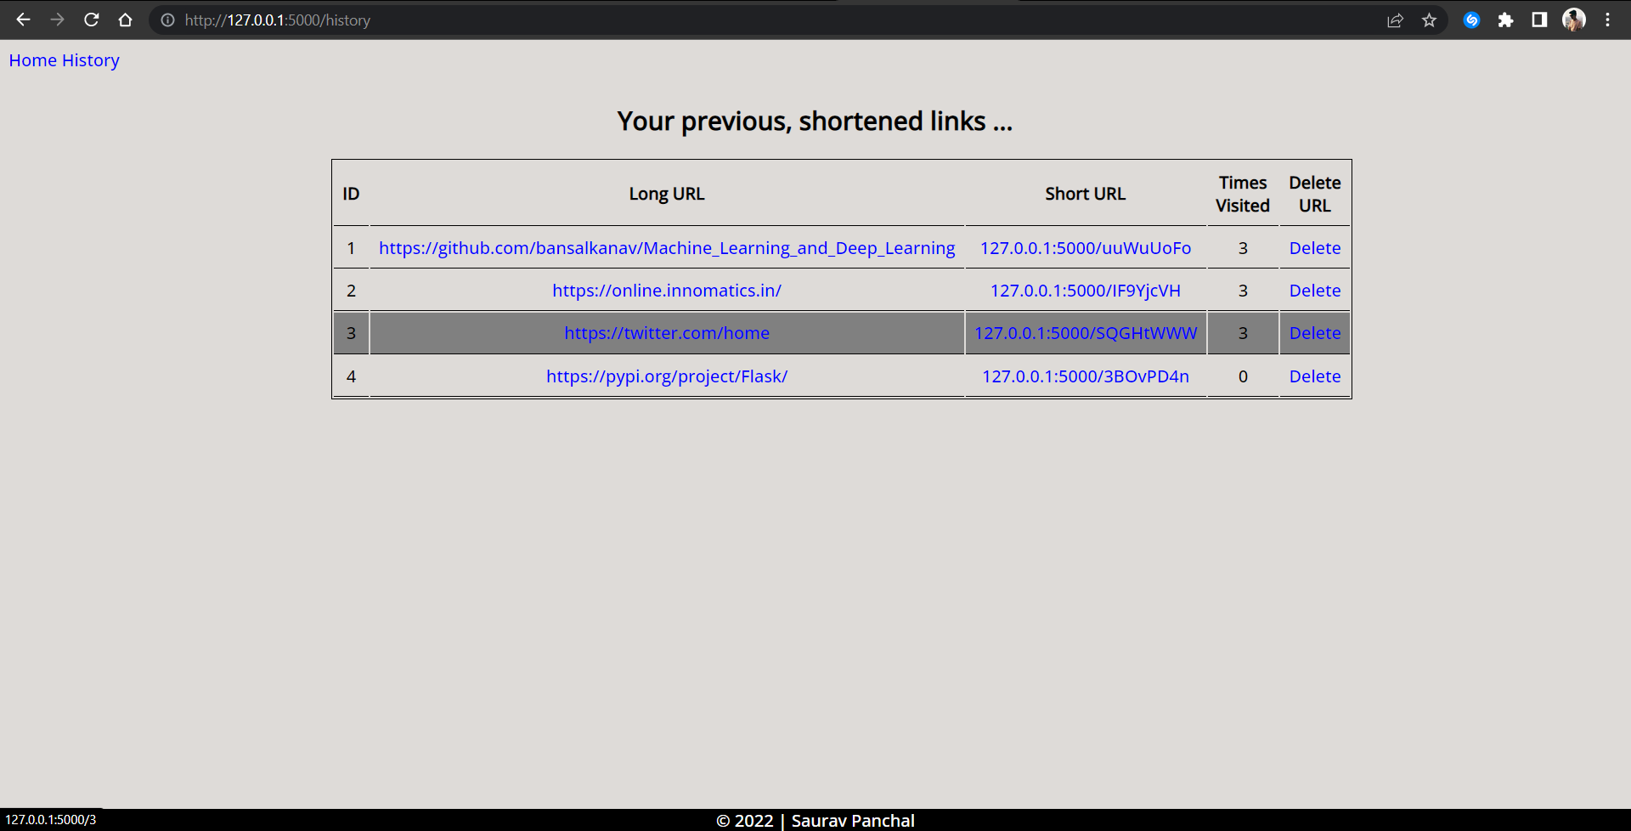

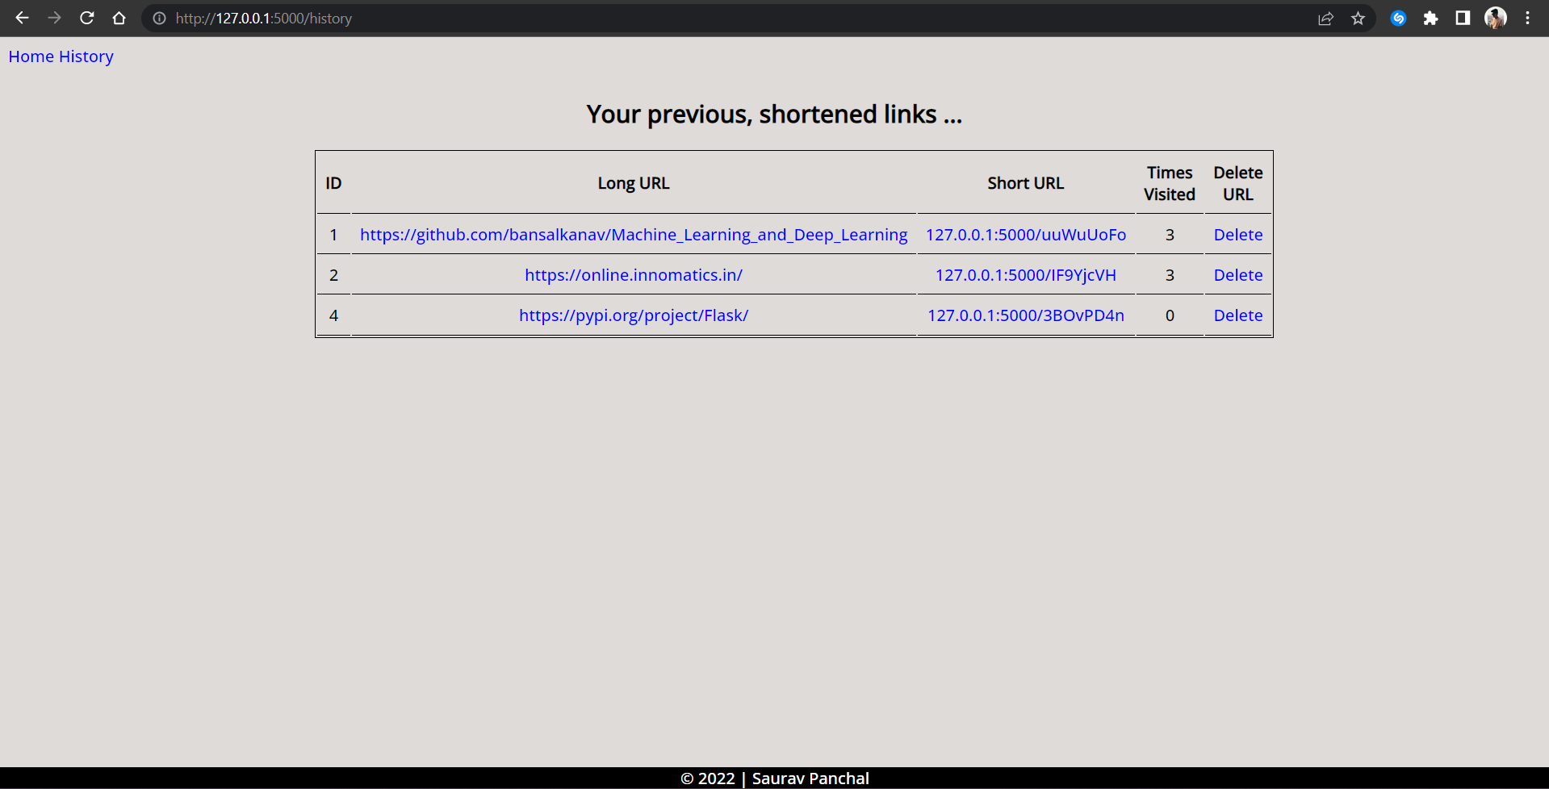

**Workflow :**

1. User will enter a valid URL in input field.
2. Then, after clicking generate short URL button, short URL will be generated and will be displayed in textarea input.
3. That short URL will be copied in clipboard with help of button.
4. That URL can be pasted anywhere to open the corresponding long URL.
5. On visiting links via short URLs it also, keeps track of times visited, which can viewed in history page.
6. Also, user can delete the mapped URLs from history page only.
7. The database is also, updated concurrently, it’s synced with FE.

*More on project* :[GitHub Repository](https://github.com/sauravpanchal/irl/tree/main/Week%203/Flask/Task%20-%203%20(Basic%20-%20URL%20Shortner%20Application))

*By :*

[*Saurav Panchal*](https://github.com/sauravpanchal)